Q1. (50 points) Chapter 3: Assume that X and Y are independent measurements with

uncertainties 𝜎_𝑥 = 0.3 and 𝜎_𝑦 = 0.2. Find the uncertainties in the following quantities:

a. 4X

1.2

b. X + 2Y

sqrt((1^2 * 0.3^2) + (2^2 * 0.2^2)) = sqrt(0.09 + 0.16) = 0.5

c. 2X − 3Y

sqrt((2^2 * 0.3^2) + ((-3)^2 * 0.2^2)) = sqrt(1.2 + 0.36) = 1.248

d. 2X − 3Y+2

sqrt((2^2 * 0.3^2) + ((-3)^2 * 0.2^2)) = sqrt(1.2 + 0.36) = 1.248 since 2 does not contribute to the uncertainty

Q2. (50 points) Chapter 3: 𝑋 and 𝑌 are two independent measurements.

𝑋 = −1 ± 1 and 𝑌 = 3 ± 2, where -1 and 3 are the means of the measurements 𝑋 and

𝑌, respectively. Also, 1 and 2 are the standard deviation (uncertainty) associated with the

measurements 𝑋 and 𝑌, respectively. Thus, these measurements can be treated as independent

random variables. Find the mean, variance, and standard deviation of the following

combinations.

a. 𝑍_1 = 𝑋 − 2𝑌

Mean: -1 - 2(3) = -7

Variance: 𝜎_𝑧^2 = 1^2 + 4(2^2) = 17

Standard deviation: 𝜎_𝑧 = √𝜎_𝑧^2 = √17 = 4.123

b. 𝑍_2 = 𝑋 + 2𝑌 + 1

Mean: 𝜇_𝑧 = 𝜇_𝑥 + 2𝜇_𝑦 + 1 = -1 + 2(3) + 1 = 6

Variance: 𝜎_𝑧^2 = 𝜎_𝑥^2 + 2^2𝜎_𝑦^2 = 1^2 + 4(2^2) = 17

Standard deviation: 𝜎_𝑧 = √𝜎_𝑧^2 = √17 = 4.123

Q3. (10 points) Chapter 4: Let X ∼ Bin(7, 0.3). Find

a. p(X = 2)

P(X = 2) = C(7, 2) * (0.3)^2 * (1-0.3)^(7-2) = (21) * (0.09) * (0.7)^5 = 0.317

b. p(X < 1)

P(X = 0) = C(7, 0) * (0.3)^0 * (1-0.3)^(7-0) = 1 * 1 * (0.7)^7 = 0.0823

c. p(X > 4)

p(X > 4) = 1 - [p(X = 0) + p(X = 1) + p(X = 2) + p(X = 3) + p(X = 4)]

P(X = 1) = 0.2167

P(X = 3) = 0.1852

P(X = 4) = 0.0897

p(X > 4) = 1 - [0.08235 + 0.2167 + 0.2668 + 0.1852 + 0.0897] = 0.1592

d. Mean: μX

7 * 0.3 = 2.1

Q4. (15 points) Chapter 4: Find the following probabilities:

a. p(X = 2) when X ∼ Bin(4, 0.6)

P(X = 2) = C(4, 2) * (0.6)^2 * (1-0.6)^(4-2) = (6) * (0.36) * (0.4)^2 = 0.3456

b. p(X > 2) when X ∼ Bin(8, 0.2)

P(X = 0) = 0.16777

P(X = 1) = 0.33554

P(X = 2) = 0.29360

p(X > 2) = 1 - [0.16777 + 0.33554 + 0.29360] = 0.203

c. p(3≤ X ≤ 5) when X ∼ Bin(6, 0.7)

P(X = 3) = 0.18522

P(X = 4) = 0.32413

P(X = 5) = 0.30203

p(3 ≤ X ≤ 5) = 0.18522 + 0.32413 + 0.30203 = 0.81138

Q5. (10 points) Chapter 4: Let X ∼ Poisson(4). Find

a. p(X = 1)

P(X = 1) = (e^(-4) * 4^1) / 1! = 0.0732

b. p(X < 2)

P(X = 0) = (e^(-4) * 4^0) / 0! = 0.0183

p(X < 2) = P(X = 0) + P(X = 1) = 0.0183 + 0.0732 = 0.0915

c. Mean: μX

4

d. Standard Deviation

sqrt(4)=2

Q6. (15 points) Chapter 4: Let Z ∼ N(0, 1). Find a constant “c” for which

a. p(Z ≥ c) = 0.1587

p(Z ≤ c) = 1 - 0.1587 = 0.8413 according to CDF table, closest value is 1

b. p(c ≤ Z ≤ 0) = 0.4772

p(Z ≤ c) = p(Z ≤ 0) - p(c ≤ Z ≤ 0) = 0.5 - 0.4772 = 0.0228 according to CDF table, closest value is

-2

c. p( −c ≤ Z ≤ c) = 0.8664

p(Z ≤ c) = (p(−c ≤ Z ≤ c) + 1) / 2 = (0.8664 + 1) / 2 = 0.9332 according to CDF table, closest value is 1.5

Q7. (10 points) Chapter 4: Read Section 4.11 (Central Limit Theorem) in your textbook. Then briefly

explain what it means.

Central Limit Theorem says that if we draw a large enough sample from a population, then the distribution of the sample mean is approximately normal, no matter what population the sample was drawn from.

Q8. (20 points) Chapter 4: Fit a Gaussian distribution 𝑁( 𝜇_𝑥, 𝜎_𝑥^2) to the following data. This means that we want to model and represent the given data, in a probabilistic way, using a Gaussian distribution. Then, sketch the distribution.

𝑋 = [ 0 , 0 , 0.1 , 0.5 , 0.9 , 0.2 , 0.1 ]

Hint: Find the sample mean and sample variance of the data. The probability density function

(pdf) of a Gaussian distribution is defined as follows

𝑓(𝑥) = (1/sqrt(2pi(𝝈_x^2)))e^((-1/(2(𝝈_x^2)))(x-𝜇_x)^2)

where 𝜇_𝑥 and 𝜎_𝑥^2 are the mean and variance of the random variable 𝑥, respectively.

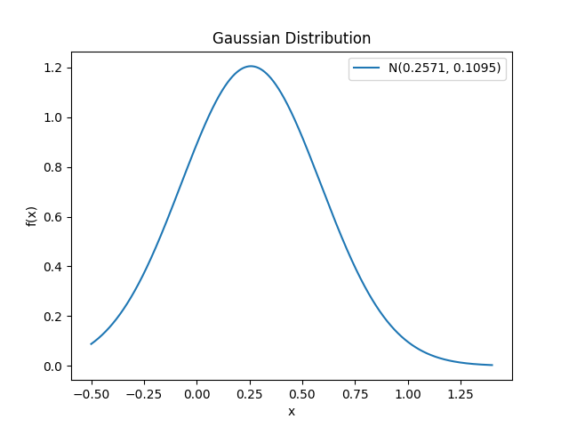

Q9. (20 points) Chapter 4: Fit a Gamma distribution Γ(𝑎, 𝑏) to the following data, where 𝑎 and 𝑏

are the shape and rate parameters of the distribution, respectively. This means that we want to

model and represent the given data, in a probabilistic way, using a Gamma distribution.

𝑋 = [ 0 , 0 , 0.1 , 0.5 , 0.9 , 0.2 , 0.1 ]

The mean and variance of a Gamma distribution can be found as follows.

𝜇_𝑥 = 𝑎/𝑏

𝜎_𝑥^2 = 𝑎/𝑏^2

mean = μ_x = (Σx) / n = (0 + 0 + 0.1 + 0.5 + 0.9 + 0.2 + 0.1) / 7 = 0.2571

variance = σ_x^2 = (Σ(x - μ_x)^2) / (n - 1) = ((0.0665)^2 + (0.0665)^2 + (0.1571)^2 + (0.2429)^2 + (0.6429)^2 + (0.0571)^2 + (0.1571)^2) / 6 = 0.0889

a = (0.2571^2) / 0.1095 = 0.6036

b = 0.2571 / 0.1095 = 2.3479